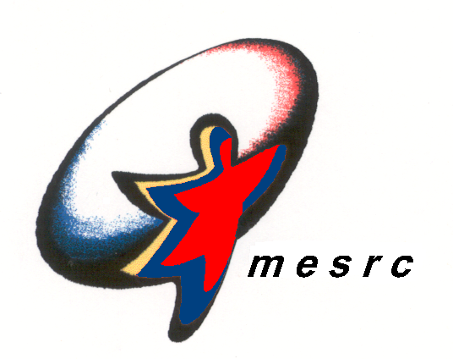  MINISTRY OF EDUCATION SPORTS & RECREATION CLUB | Photo

Renewal Form for Associate Membership

Date: ___________________

Name: ___________________________________ Membership No.; ____________________

- Please provide us a photo if you would like to change the photo on the membership card.
- The membership fee is $60.00 for three years. The cheque should be made payable to ‘MESRC.’
- Please fill in the necessary information below if you wish to update us with any change.

PARTICULAR |  | CURRENT EMPLOYER (if any)
Home Tel No.: |  | Company Name:
Office Tel No.: |  | Designation:
HP No.: |  | Office Tel No.:
Home Address: |  | Office Address:
 |  | Joined Date:
E-Mail Address:

I wish to renew my membership. I am aware that the privileges and use of the facilities stated herein are subjected to the Club’s Rules and Regulations dictated by the Management Committee.

___________________________________________________ _____________________________
Signature of Applicant Date

